Interactive Media – Unit 1 – LO2

Lesson 8 – VG Development – Media and Interactivity

Worksheet

1. Starter – Can you list the different ways in which information is shown to the user on Microsoft Word?
2. Task 1 – Take a look at the following image and answer the questions below:  
   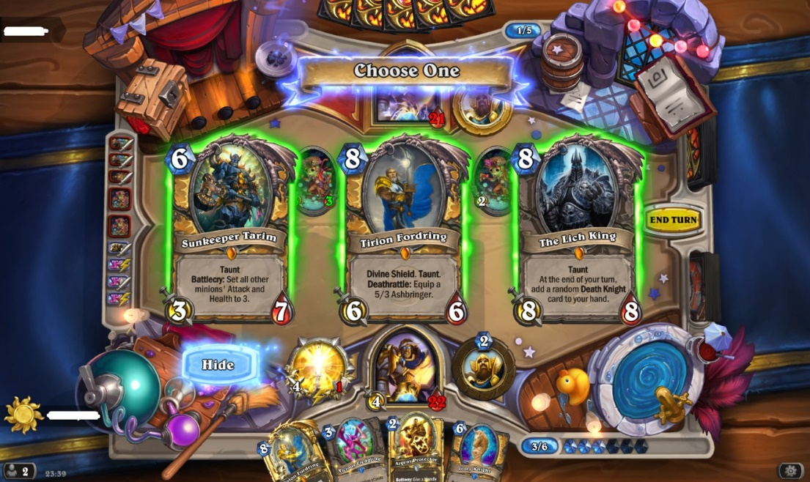  
     
   1. **BRONZE** – Make a list of the points where information is being shown to the user.
   2. **SILVER** – Which of those points are clearer than the others?
   3. **GOLD** – Is it clear what every bit of information does?  
        
        
      **Challenge** D – What could you change to make it clearer?
3. Task 2 – Select a VG that you are familiar with, and as with the previous task, list how the product is actually interactive.
   1. **BRONZE** – List the interactive features of the product. Include a screenshot with the task.  
      Note: You may find that some VGs are blocked, search the image before listing the features.
   2. **SILVER** – Describe how 5+ of those features are interactive.
   3. **GOLD** – Explain the effects those 5+ features have on the product. Are they positive or negative?  
        
        
      **Challenge** D – What could you improve about the negative features?
4. Plenary – Select another VG that you are familiar with, different to the previous tasks.
   1. **BRONZE** – Take a screenshot of the game, highlight the points where information is being conveyed to the user.
   2. **SILVER** – Explain which of these show off the information well and which could do with improvements.
   3. **GOLD** – List the interactive features of the VG.